IQTools with RCAL

Getting Started Guide

For use with the Keysight U9361 RCAL Module

2020-06-11 Ed Barich

Table of Contents

IQTools with RCal 4

Software Installation Process 5

Items you will need to perform the installation 5

Software Installation Configurations 5

Software on a PC 5

Software on the Analyzer or Scope 5

Install the U9361Y_RCL RCal License 5

Software on a PC 5

Software on the Analyzer or Scope 5

Install the Matlab Application 6

Install the IQTools Software 6

Install the RCAL Application Software for IQTools 6

Install the VSA Software 6

Hardware Installation Process 7

Set up the hardware 7

Alternate Hardware Setup Configurations 7

Receiver is a Scope instead of Signal Analyzer 7

Software is installed on a PC 7

Powering-Up the RCal Module 7

Running the Applications 8

Start the VSA Application 8

Start the IQTools Application 8

Performing the RCal Calibration 12

Connecting the RCal Module 12

Initiate the Calibration 15

Managing Calibration Speed and Repeatability 18

Using RCal with Infiniium Scope as the VSA Receiver 19

Infiniium Scope Directly as a Receiver 19

Infiniium Scope with RF Downconverter as a Receiver 19

Troubleshooting 21

VSA Error Messages 21

Matlab Error Messages 21

# IQTools with RCal

IQTools is an example MATLAB application to generate multi-tone, pulsed radar, digital modulation and high-speed serial data signals. It works in conjunction with Keysight high-speed AWGs and Vector Signal Generators. This document describes how the U9361 RCal Receiver Calibration Module can be used with IQTools to improve VSA receiver accuracy. With better receiver accuracy, the IQTools program can used to correct the RF source waveform for improved magnitude and phase flatness.

This application supports using either an XSA-Series Signal Analyzer or an Infiniium Scope as the receiver to be controlled by the VSA application.

# Software Installation Process

## Items you will need to perform the installation

* Matlab software (installation files from MathWorks along with necessary licenses)
  + Matlab version 2019A or later
  + Instrument Control Toolbox
* IQTools software
  + Version 2019-10-24 or later (on Keysight.com website, search “IQTools”)
* RCal Matlab files for use with IQTools
  + Found in folder labeled “iqtools_Mohawk_Files”
* A U9361Y_RCL license for the RCal module
* U9391 RCAL Module (F or M model)
  + Accessories:
    - Cable-Assembly USB 3.0 Type-A Plug to Type-C Plug, 1 meter long
    - Cable Assembly-Coaxial BNC Male to SMB-Female, 1 meter long
* 89600 Vector Signal Analyzer (VSA) software
* A VSA-compatible receiver:
  + N9040B or N9041B UXA Spectrum Analyzer, or
  + UXR Infiniium oscilloscope

## Software Installation Configurations

There are two possible software installation configurations:

### Software on a PC

If you want to run the IQTools application on a PC, the Matlab, IQTools, RCal and VSA software should be installed there. Since the RCal module is controlled by Matlab code, its USB cable will need to be connected between the PC and the RCal module, which may limit the physical reach of the module.

### Software on the Analyzer or Scope

If you want to run the IQTools application on the Analyzer (or Scope), the Matlab, IQTools, RCal and VSA software should be installed there. Since the RCal module is controlled by Matlab code, its USB cable will need to be connected between the analyzer and the RCal module, which may be physically more convenient since the RCal will be calibrating the RF input of the analyzer.

## Install the U9361Y_RCL RCal License

### Software on a PC

Install the U9361Y_RCL license on the PC using Keysight License Manager

### Software on the Analyzer or Scope

Install the U9361Y_RCL license on the Analyzer or Scope using Keysight License Manager

## Install the Matlab Application

Install the Matlab and Instrument Control Toolbox software on the target PC using the Administrator login and the installation processes recommended by MathWorks.

## Install the IQTools Software

Install the IQTools software on the target PC using the Administrator login. Note the location of the “iqtools” folder where the Matlab files are installed.

## Install the RCAL Application Software for IQTools

Copy the files in the “iqtools_Mohawk_Files” folder to the “iqtools” folder.

* NOTE: Some files in the “iqtools” folder will be over-written. This is normal.

## Install the VSA Software

Install the VSA software on the target PC using the Administrator login. Use recommended installation process.

**This completes the software installation process.**

# Hardware Installation Process

## Set up the hardware

Connect the hardware as shown in the following diagram:

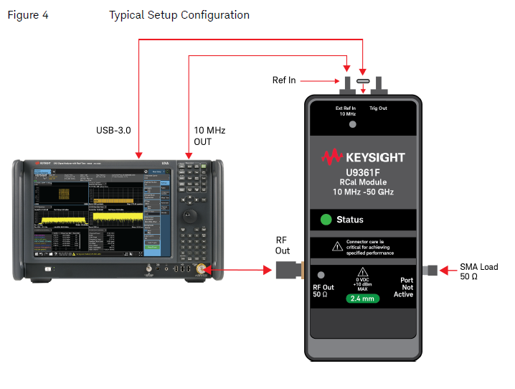

## Alternate Hardware Setup Configurations

### Receiver is a Scope instead of Signal Analyzer

* + RF Output of U9361 should be cabled to Channel 1 input of scope.
  + Ref In of U9361 should come from 10MHz Reference Output of scope

### Software is installed on a PC

* + USB port of U9361 should be connected to USB-3.0 port of the PC, not the analyzer.

## Powering-Up the RCal Module

Shortly after connecting the RCAL module with the USB cable, the Status light on the RCAL unit will turn green, indicating that the module is ready for calibrations. Note that no signal is present at the RCal module output, since the RCAL module powers-up with its RF output power turned off.

**This completes the Hardware Installation Process.**

# Running the Applications

## Start the VSA Application

1. Prior to starting the VSA app, use Keysight Connection Expert to find the target receiver (either Signal Analyzer or Oscilloscope) that will be controlled by the VSA.
2. Start the VSA application.
3. Configure the VSA hardware configuration to use the target receiver.

## Start the IQTools Application

1. Start the Matlab application
2. In the “iqtools” folder, select and run the “iqtools.m” script.
3. The main panel of iqtools will appear:

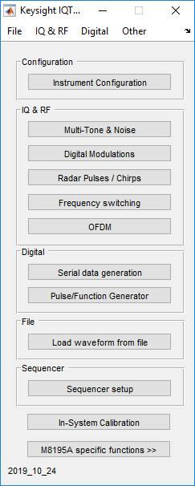

1. Press the “Instrument Configuration” button to get the Instrument Configuration display:

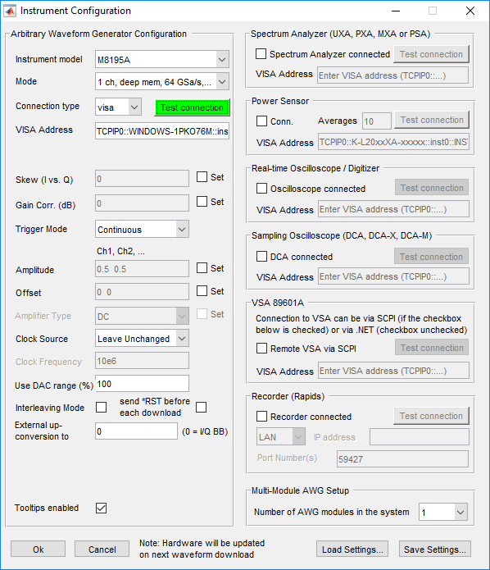

If you will be using an Arbitrary Waveform Generator as a signal source, configure the Model and VISA address, then press “Test Connection” to connect to the AWG. If the button is GREEN, the connection has been established.

1. Going back to the Main IQTools panel, press the “Digital Modulations” button to get the Digital Modulations panel shown below:

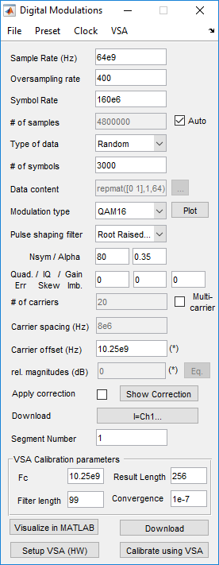

Configure the Digital Modulations panel for the waveform that you want to generate. In the case above, we are generating a QAM-16 signal with 160MSymbol/sec rate at a 10.25GHz center frequency. Press the “Download” button to download the waveform to the AWG.

1. Connect the signal generator RF output to the target VSA receiver RF input. To configure the VSA to demodulate and display the signal, press the “Setup VSA (HW)” button on the Digital Modulations panel. The VSA display should look like this:

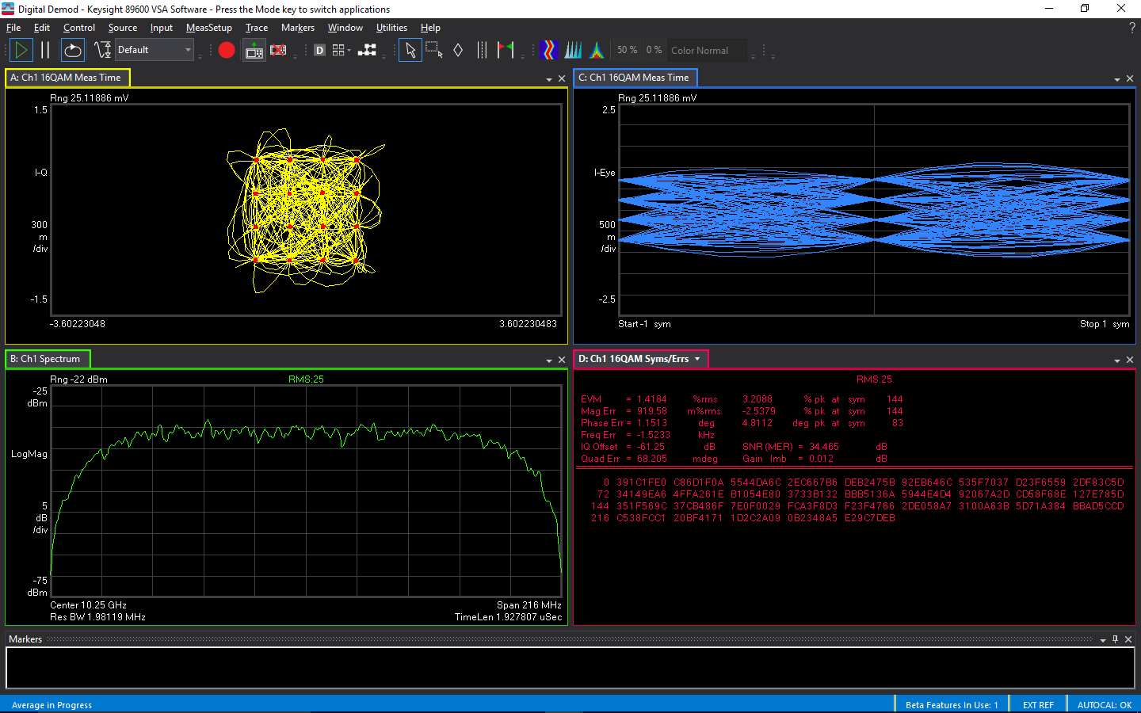

[NOTE: The Setup VSA process may leave the analyzer with a low RANGE value that will be too low for the RCal calibrator signal. The maximum RCal output power is about -6dBm, so you may need to adjust the VSA Range level to a minimum -6dBm value during calibrations.]

# Performing the RCal Calibration

Having performed the previous steps, you are ready to perform the RCal calibration.

## Connecting the RCal Module

1. Disconnect the signal generator from the target VSA receiver and replace it with the RCal module. The RF Output of the RCal module should be placed at the calibration reference plane (point of connection where the signal generator output will be measured after calibration of the receiver).
2. On the IQTools Digital Modulations panel, click “VSA > Receiver Calibration using Mohawk” as shown below:

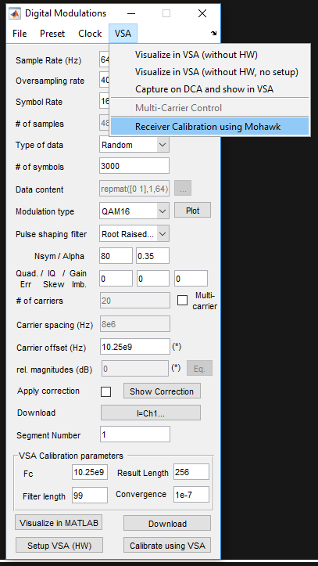

This will bring up the RCal GUI shown below:

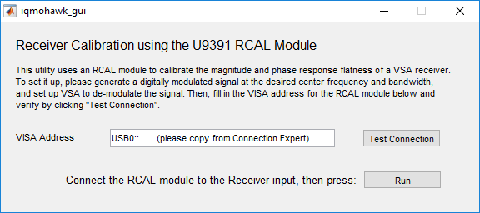

1. You will need the VISA address of the RCal module. Start the Keysight Connection Expert application to find the VISA address of the Module:

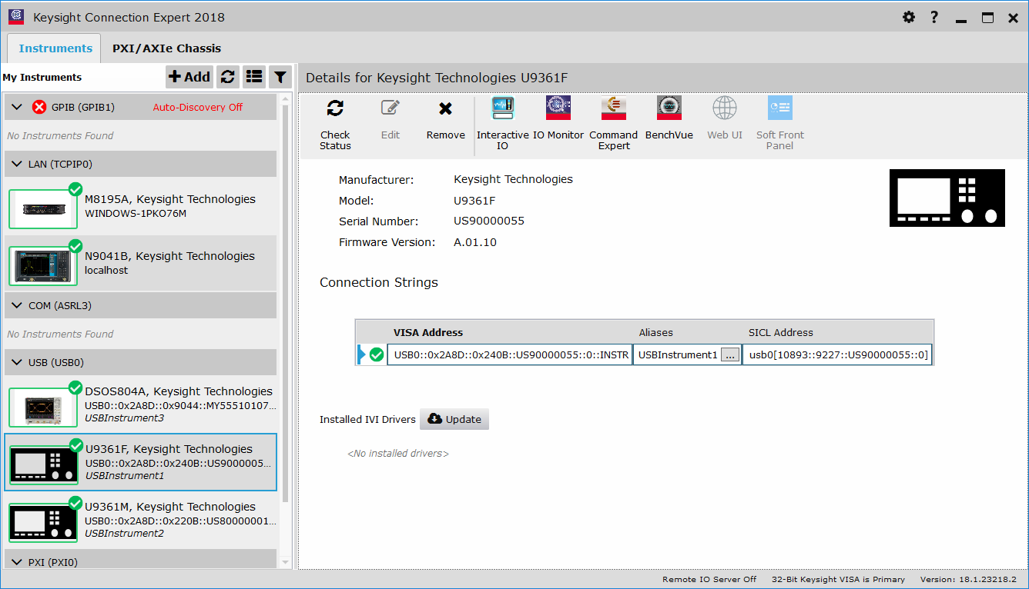

Copy the address and paste it into the RCal GUI. Press the “Test Connection” button:

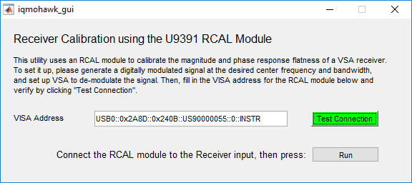

Pressing the “Test Connection” button, will connect the RCAL module to the GUI, which should turn the button green [failure to connect will turn the button red].

## Initiate the Calibration

To initiate the calibration process, press the “Run Cal” button on the RCal GUI. The first time the calibration has been run, the Matlab Command Window will display “Reading RCAL ABS Data from EEPROM…”, indicating that the calibration data internal to the RCAL unit is being transferred to the RCAL application. After about 30 seconds, this process completes, and you will see a multi-tone signal on the VSA display: 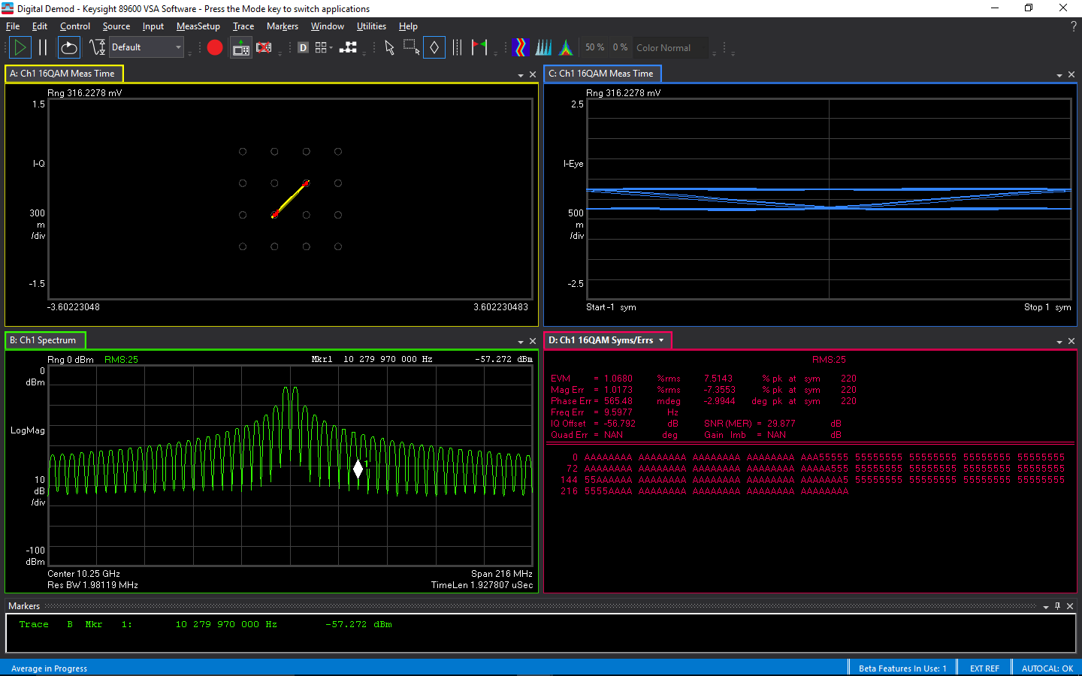

When the calibration completes, you should see a Matlab figure showing the results of the calibration:

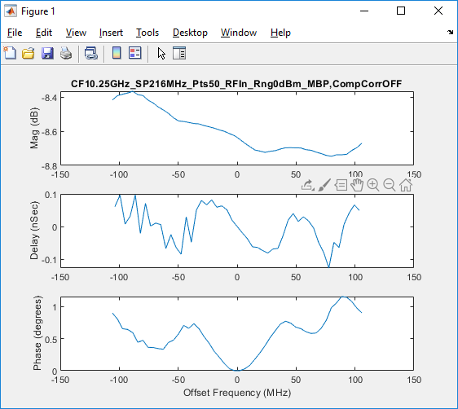

The top graph displays the measured magnitude response of the receiver. The middle graph shows the group delay response and the bottom graph shows the phase response. The label “CompCorrOFF” in the title indicates that the measurement was made with the VSA corrections turned OFF. At the completion of the calibration, the corrections are automatically turned ON as shown in the VSA Corrections display shown below:

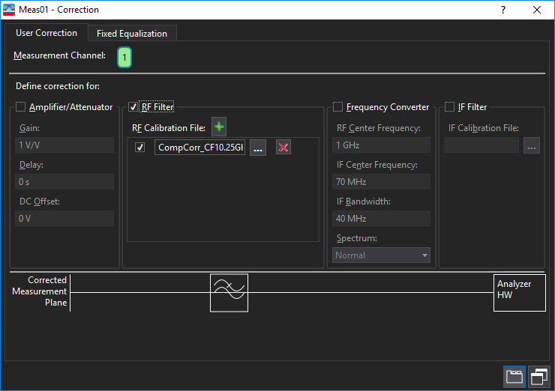

Note that the “RF Filter” box is checked, indicating that the RCal Complex Correction is being applied. The location of the RF Calibration File is shown in the panel. The file is stored in a “.s2p” format in the following folder:

…\iqtools\S_parameters

With file names starting with “CompCorr_...”, followed by receiver settings descriptions. From the VSA Corrections panel you can select and apply any of these calibrations but remember that for best calibration accuracy they must be used with the analyzer in the same configuration state as when the calibration was performed.

To check for the repeatability of this calibration, you can run the calibration a second time with the Complex Correction turned ON, resulting in the following graphs:

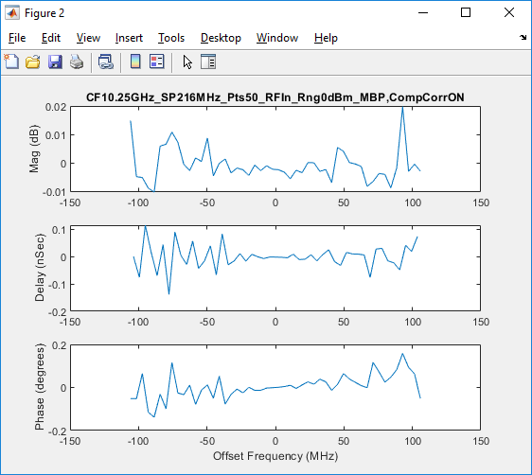

Note that the title includes the label “CompCorrON”, indicating that the RCal Complex Correction was applied when the measurement was made. As shown in the graphs, the resulting magnitude and phase deviations are greatly reduced by the application of the complex corrections.

If you want to run the calibration again, but without RCal corrections applied, de-select the “RF Filter” box on the VSA Corrections panel.

## Managing Calibration Speed and Repeatability

The calibration process is dependent on the analyzer configuration and the RCAL application configuration. Below are some tips on managing calibration speed and repeatability

* Number of RCAL points – The RCAL GUI defaults to a value of 51 calibration points in the measurement span. As the number of points increases, the length of the calibration time increases proportionately. [Note that the number of measurement points is a parameter in the “iqmohawk.m” script but is not accessible from the RCal GUI.]
* Repeatability improves with better signal to noise ratio
  + Minimize analyzer input attenuation and RF path loss to improve repeatability.
  + The RCal algorithm tries to maintain a minimum signal-to-noise ratio by averaging multiple measurements when the SNR gets low. This will increase measurement time.
  + The RCal module RF output power drops by about 10dB above 50GHz center frequency due to the use of 3rd harmonic signal. This will increase averaging and measurement time.

# Using RCal with Infiniium Scope as the VSA Receiver

If an Infiniium scope will be used as the VSA receiver instead of an XSA signal analyzer, the following methods should be used.

## Infiniium Scope Directly as a Receiver

The Infiniium scope can be used directly as the VSA receiver if its frequency range is high enough to capture the RF signal of interest. The new Keysight UXR series of scopes with bandwidths up to 110GHz is a candidate for this application. All of the setup and measurement instructions shown above for RCal operation should apply in this case.

## Infiniium Scope with RF Downconverter as a Receiver

If the Infiniium scope does not have sufficient bandwidth to capture the signal of interest, a fixed-tuned RF downconverter can be used to mix the RF signal down to an IF frequency range that the scope can capture. To allow the VSA software to take the downconversion into account, the VSA User Correction panel will need to be adjusted to include the frequency conversion (prior to the RCal calibration):

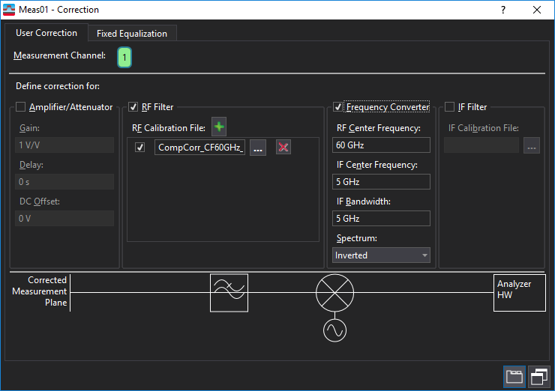

The adjustments for an example 60GHz to 5GHz inverting downconverter are:

1. Check the “Frequency Converter box.
2. Set the “RF Center Frequency” value equal to the RF input center frequency of the downconverter.
3. Set the “IF Center Frequency” value equal to the IF output center frequency of the downconverter.
4. Set the “IF Bandwidth” value to the desired measurement bandwidth.
5. Set the “Spectrum” value to match the downconverter mixing sign (inverted or non-inverted). [Note: Having the mixing sign correct is essential to getting valid calibrations. I you are using a spectrum analyzer in zero-span mode as the fixed-frequency downconverter, make sure you are using the correct mixing sign for the analyzer mixing mode.]

With these settings, the VSA spectrum will be shown with a 60 GHz center frequency, even though the signal measured by the scope is actually centered at 5 GHz IF, as shown below:

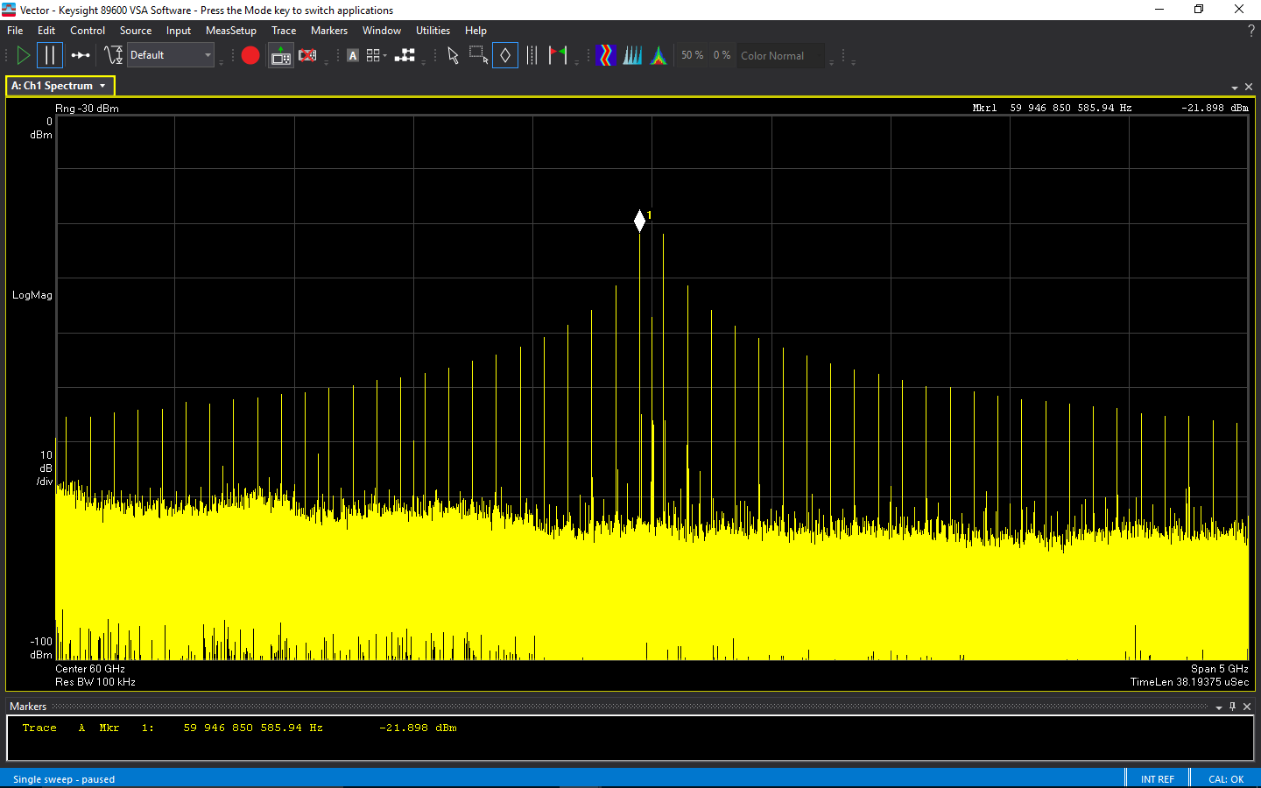

# Troubleshooting

Here are some things to check when the RCal application behaves incorrectly:

## VSA Error Messages

* **VSA Overload errors** – During the calibration, watch for “OVLD” messages on the VSA display. This could indicate that the RCal output is overloading the receiver input. If this occurs, increase the Range level and rerun the calibration.

## Matlab Error Messages

If the RCal measurement appears to be stuck (no action on VSA display), check the Matlab Command Window for the following warning messages:

* 'RCAL VISA address must be specified' – The RCal module VISA address was not entered into the RCal GUI address window when you tried to launch the calibration.
* 'Initializing VSA software, which will take a REALLY long time...' – The VSA application was not started prior to running the RCal calibration. It may take a minute or so for the Matlab code to launch the VSA application. Be patient.
* 'WARNING: Signal is off by xxx MHz; Check 10MHz Reference from receiver to RCAL module and RF path from RCAL Out to receiver Input' – The RCal module generated a CW (unmodulated) signal, but it was not found at the specified center frequency. The RCal module needs a 10MHz reference signal from the analyzer to phase lock its internal reference. The “Ext Ref IN” LED on the U9361 top panel should be GREEN.
* 'WARNING: Signal to Noise Ratio is negative dB; Check RF path from RCAL Out to receiver Input' – The measured signal-to-noise ratio is below the minimum required level. Either the RF path loss from the calibrator to the analyzer is too high to make a valid measurement or you forgot to connect the calibrator to the RF path.